3.5 I can adjust settings so that others can access IT tools and devices for collaborative working

When working online there can be occasions where you need to adjust your settings or help others to adjust their settings so that others can work collaboratively with you. For example, the teaching for my course is carried out via online tutorials. Originally the application used was Microsoft Teams however this platform presented difficulties for some including individuals who use different devices such as their smart phones and it was not possible to share recording of the tutorials outside of the administrator of the accounts organisation. Adobe Teams Connect was found as a work around for this. It allowed for recordings of the tutorials to be shared and it could also be accessed using smart phones and tablets alongside desktop/lap top computers on numerous operating systems as well as being a free and open source application.

I have been required to use Github as a tool to work collaboratively as part of my coursework however when I tried to use the website it was not compatible with the Microsoft Edge browser. Instead I opened Google Chrome to use the website and this resolved the problem. I have more than one browser downloaded to my desktop as occasionally compatibility issues such as this arise. Some websites also are easier to use in different web browsers. I prefer to use Google Chrome for example due to the layout, easy to use extensions such as ad blocker and compatibility with other open source google products such as Gmail, YouTube and Google Drive.

Github is a free open source website which has allowed me to upload and share documents with my tutor. By sharing the URL my Tutor can view the assignments I have uploaded. Setting the account to public allows others with Github accounts to view your projects (repositories) and suggest changes. The following example shows my options regarding who can view my repository on Github;

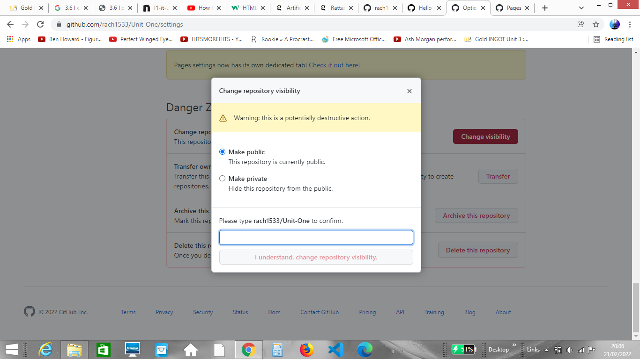

When creating a webpage it is important to be mindful of accessibility issues. For example using clear font and a larger font size will make your web page easier to read and may help those with issues with their vision or those who have dyslexia. Tagging photos with text can help users who have issues with their vision to use assistive software to describe the photo. When using audio content; subtitles or written summary of content can be used to help those with hearing difficulties to access your content.

Example of bold, clear font on my webpage set on a neutral background;

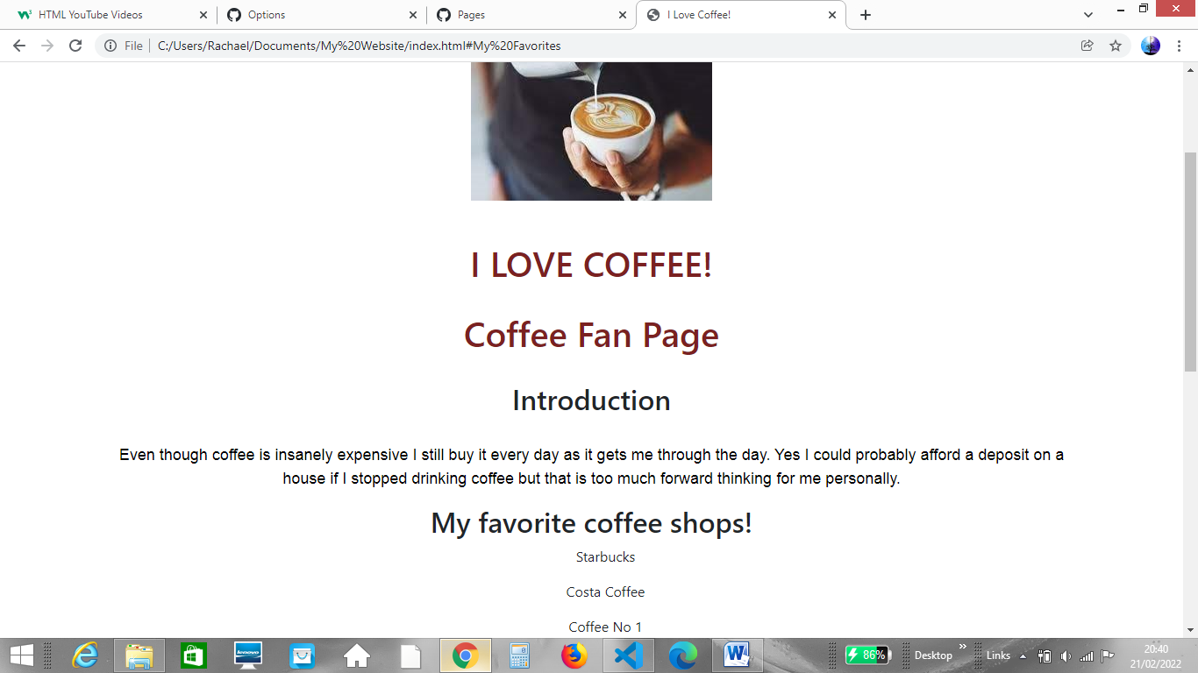

There are also simple settings you can use yourself to help with accessing content such as Ctrl+ to increase font/image size, Ctrl- to decrease font/image size, using the zoom bar to zoom in and out, moving your screen away from light sources to reduce glare as well as reducing or increasing the screen brightness/ colour saturation of your monitor.

Inthe following example I have used the Zoom bar in the bottom right Microsoft Word to zoom in on the text and make it larger, setting the zoom level to 188%;

